Task 4: How to Debug CSS
### Common CSS Issues and How to Debug Them

CSS can sometimes behave unexpectedly due to factors like specificity, inheritance, or layout quirks. Debugging these issues requires a methodical approach, and browser developer tools are indispensable for identifying and fixing them.

### Common CSS Issues:
1. **CSS Specificity Problems**: When multiple CSS rules apply to the same element, more specific rules take precedence. Less specific rules may be ignored.
2. **Inheritance and Overriding Styles**: Some properties are inherited from parent elements, while others are not. This can cause unexpected behavior.
3. **Layout and Positioning Issues**: Elements might not align or display as expected due to issues with `float`, `flexbox`, `grid`, or other layout models.
4. **Box Model Confusion**: Problems can arise when margins, padding, and borders don’t behave as expected, often due to incorrect use of `box-sizing`.
5. **Responsive Design Problems**: CSS styles may not adapt correctly on different screen sizes due to improper use of media queries or units.

### Step-by-Step Guide to Debugging with Browser Developer Tools

#### Step 1: Open Developer Tools
1. Right-click on the webpage and select **Inspect** (in Chrome, Firefox, Edge, etc.).
2. This will open the **Elements** tab, showing the HTML structure and associated CSS.

#### Step 2: Inspect the Problematic Element
1. Use the **Elements** tab to navigate the HTML structure.
2. Hover over different elements to see them highlighted on the page.
3. Click on the element that’s causing problems to view its CSS styles in the **Styles** pane on the right.

#### Step 3: Check for Overwritten or Inactive CSS Rules
1. The **Styles** pane shows all CSS rules applied to the selected element.
2. **Crossed-out styles** indicate they are overridden by more specific rules.
3. You can see which styles are taking precedence due to CSS specificity. If a rule is not being applied, look for more specific selectors.

#### Step 4: Test CSS Changes Live
1. You can **edit CSS properties** directly in the **Styles** pane.
2. Try modifying, adding, or removing styles to see how they affect the page in real-time.
3. This is a great way to quickly prototype fixes without changing your actual code.

#### Step 5: Check for Responsive Design Issues
1. In the **Device Toolbar** (accessible by clicking the small device icon in the top-left corner of DevTools), you can simulate different screen sizes.
2. Test how your page looks on various devices and orientations (e.g., mobile vs. desktop).
3. If issues arise, inspect the relevant elements and adjust CSS media queries.

#### Step 6: Use the Box Model Inspector
1. At the bottom of the **Styles** pane, you’ll see the **Box Model**.
2. This visualizes the element's `margin`, `border`, `padding`, and `content` box.
3. Use this tool to debug layout issues, especially when elements aren’t sizing or aligning correctly.

---

### Real Example of a CSS Issue and How to Debug It

#### Issue: A Button's Hover State is Not Changing Color

##### Scenario:
You have a button on your webpage that’s supposed to turn green when hovered over, but it stays its default color instead.

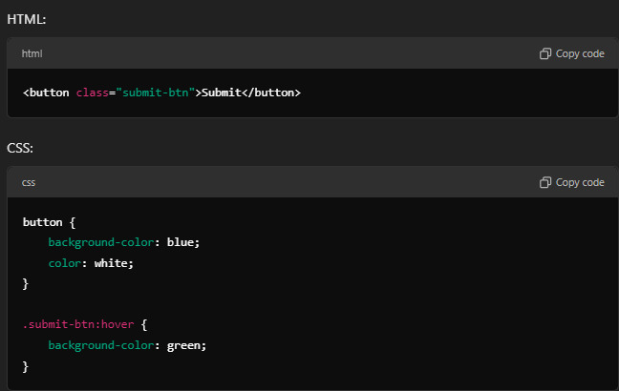
##### Step-by-Step Debugging:

1. **Inspect the Button:**
- Right-click on the button and choose **Inspect**.
- In the **Elements** tab, the `<button class="submit-btn">Submit</button>` element will be highlighted.

2. **Check Applied Styles:**
- In the **Styles** pane, look at the `button` and `.submit-btn:hover` styles.
- You see that the `button` rule is applied, but the `.submit-btn:hover` rule appears crossed-out or not applied.

3. **Investigate the Problem:**
- Check for specificity issues. If another CSS rule like `button:hover` or `.another-class:hover` is higher in the list and not crossed-out, it’s likely overriding `.submit-btn:hover`.
- You may also find that the hover style is incorrectly written (e.g., typo in the class name) or a more specific rule is taking precedence.

4. **Fix the Issue:**
- If another more specific rule is overriding `.submit-btn:hover`, you can increase the specificity by using a more specific selector, e.g.:
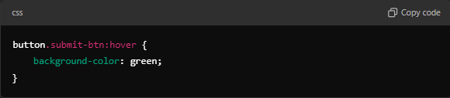 - If the issue was a typo or selector problem, correcting the class name would resolve it.

5. **Test the Fix Live:**
- Edit the CSS directly in the **Styles** pane to test your solution. If the button hover now works as expected, you’ve confirmed the issue.

6. **Apply the Fix in Code:**
- Once the live test works, apply the fix in your CSS file and test again.

---

### Debugging Techniques Summary:
1. **Use the Inspector** to find the specific element and CSS rules that are causing issues.
2. **Identify overridden or inactive styles** in the **Styles** pane.
3. **Test changes live** in the browser to quickly prototype solutions.
4. **Check the Box Model** for layout issues related to margins, padding, or borders.
5. **Simulate different devices** to identify and fix responsive design problems.

By following these steps, you can systematically troubleshoot and resolve common CSS issues.

